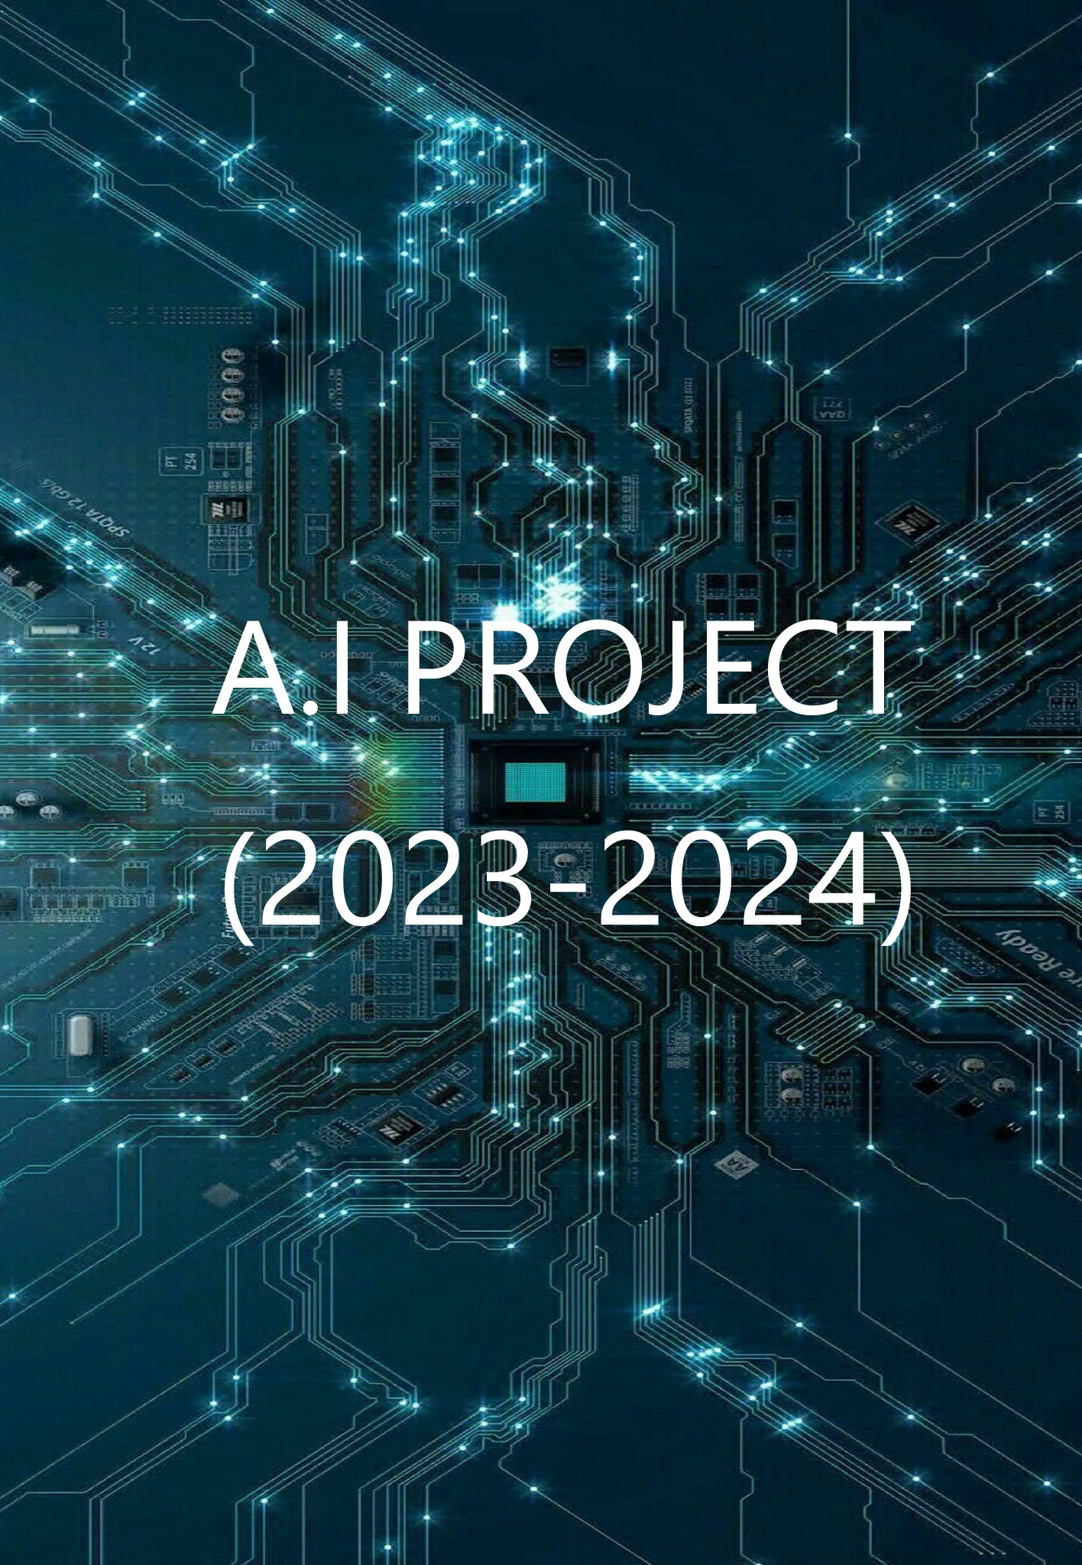

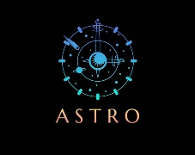 **A.I PROJECT (2023-2024)**

**INTRODUCTION**:

Artificial intelligence is the simulation of human intelligence processes by machines, especially computer systems. Specific applications of AI include [expert systems](https://www.techtarget.com/searchenterpriseai/definition/expert-system), [natural language processing](https://www.techtarget.com/searchenterpriseai/definition/natural-language-processing-NLP), speech recognition and [machine vision](https://www.techtarget.com/searchenterpriseai/definition/machine-vision-computer-vision).

**DETAILS ABOUT PROJECT**:

PROJECT NAME : ASTRO369

SCHOOL : ST.JOHN’S SENIOR SECONDARY SCHOOL

TEACHER : MANOJ KUMAR SIR

DONE BY : MUKESHWAR RAUDRA

CLASS : XI SEC : ‘B’

**PURPOSE OF ASTRO369**:

The ASTRO369 was actually made for the purpose of avoiding obstacles

and it can be controlled by Bluetooth and voice of user these features are built in

this bot because in case if a space ship revolves around the earth or when it is

crossing asteroid belt of our solar system then that time we can change the mode

to obstacle avoidance because we can avoid the meteoroid to attacks the

spaceship and we can also control the spaceship from earth by passing signals

like Bluetooth and through voice of command Centre also so this was a little bit of

starting idea to create a new era in technology and expanded space research

these are some of the purpose of ASTRO369

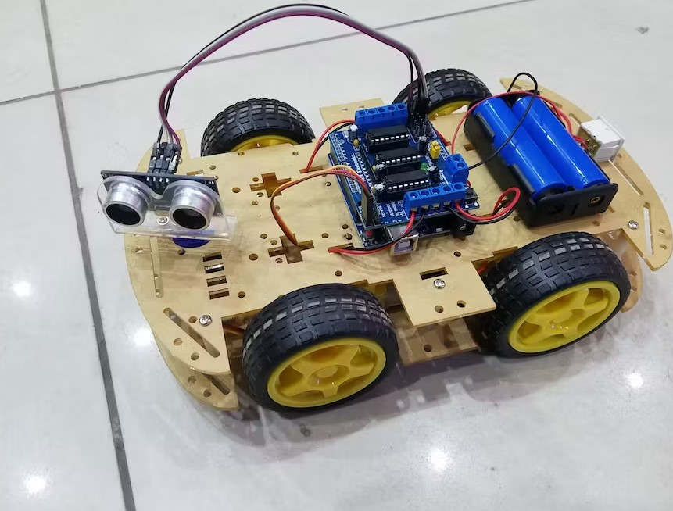

A S T R O

**FUNCTIONS**:

ASTRO369 can be used to detect the objects in the surroundings and also it

Sends a signal from ultrasonic sensor and object reflects the signal and then send back to

The sensor then it processed by ARDUINO UNO and then passes the information to the

Motor shield L293D that motor controls the 4 wheels to move according to the information

Given by the arduino then astro369 avoids the object and move on it can also controlled by

BT(Bluetooth) using specific app name as [BT RC CAR] when we connect to the car we can

Able to perform moves manually operating system and also that it can be controlled by

Voice of user for that we need specific app known as [ arduino rc control ] so that these

Ideas can be encouraged and make a new era in space research and automobile industry

So that these are some functions of ASTRO 369



**COMPONENTS** :

* Arduino UNO
* Motor shield L293D
* DC motors
* Servo motor
* Wheels
* Battery
* Battery adapter
* Jumper wires
* Chassis body (plastic)
* Ultrasonic sensor clamp (plastic)
* M3 / 3mm nuts
* Slotted minus M3 (screws)
* Screw driver
* Soldering
* feviquick
* Switch
* Bluetooth module
* USB A-B cable

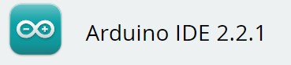**SOFWARE**:

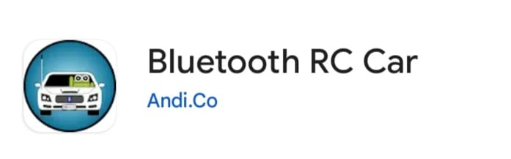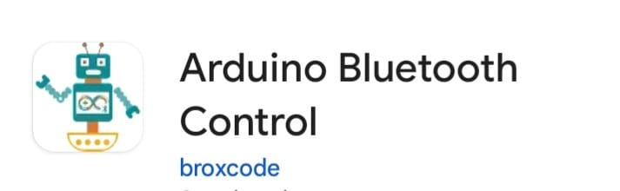



**COMPONENTS:**

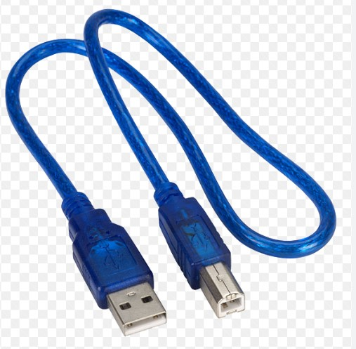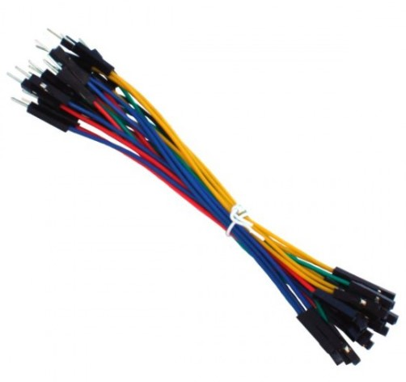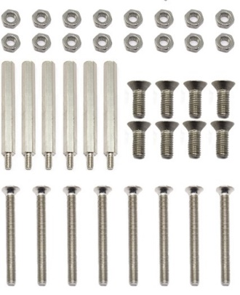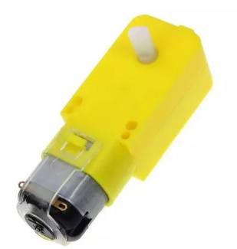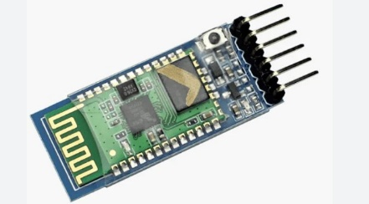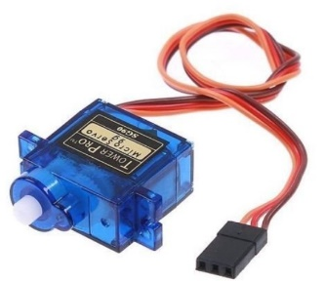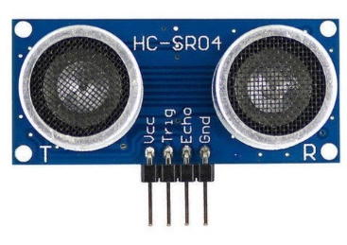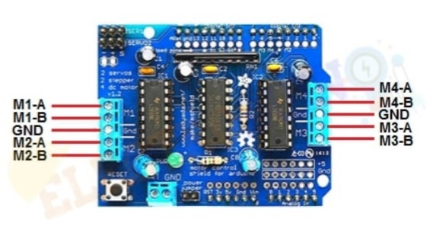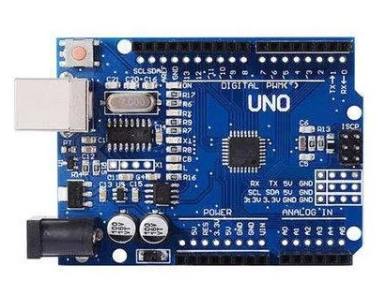



**CIRCUIT DIAGRAM:**

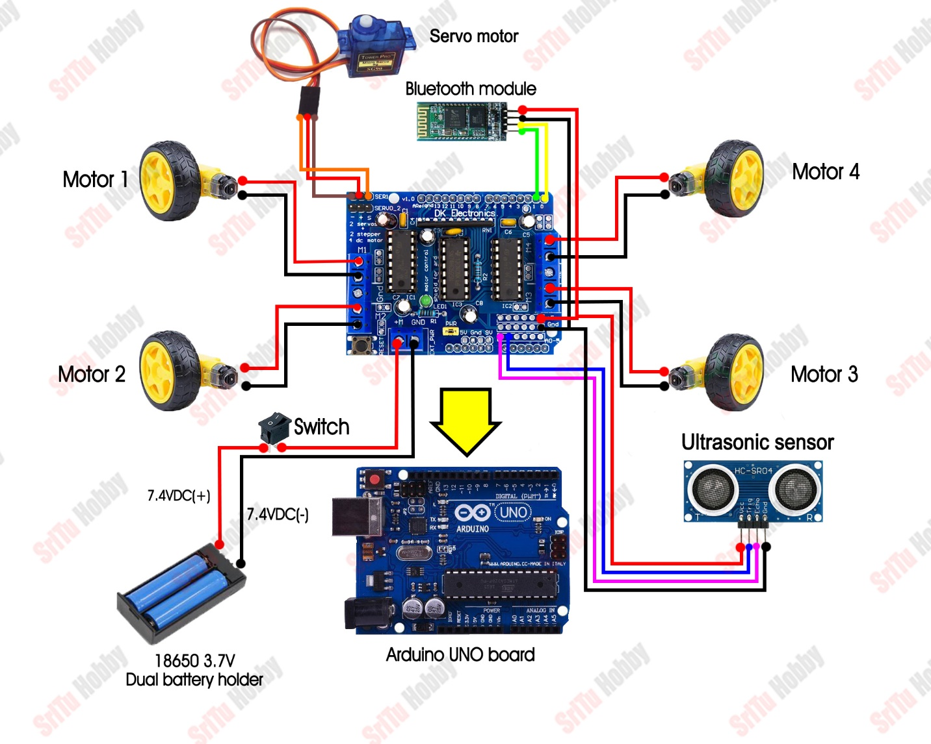

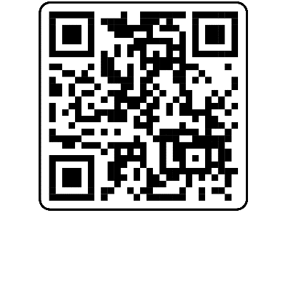**SOURCES:**

* 3D model of this project can be refer by scanning 🡪

This QR code

* Refered youtube videos are:

1. <https://youtu.be/aE_J7B-O4VQ?si=-9s7UHFCbwNsX1HT>

for connections and uploading the code

process

1. <https://youtu.be/aIJiBayh1To?si=YUv3XFTo82plABs-> for assembling the parts

* Apps : <https://play.google.com/store/apps/details?id=braulio.calle.bluetoothRCcontroller&hl=en_IN&gl=US> for controlling ASTRO369 by remote

<https://play.google.com/store/apps/details?id=com.broxcode.arduinobluetoothfree&hl=en&gl=US> for controlling ASTRO369 by voice of user

